You can now call NHS 111 to get support if you’re in a mental health crisis
From the end of April 2024, if you (or someone you support) is experiencing a mental health crisis, you can call NHS 111 and select option 2 for 24/7 access to urgent mental health support. This is a national change, meaning you can call NHS 111 for help wherever you are in the country.

Does this mean the Crisis Teams are changing?
No. Local Crisis Teams are not changing – this is just a new telephone number to call to help you access support in a crisis.

I usually call a local number to reach the Crisis Team. Will those still work?
Yes, these local and 0800 numbers are going to stay in use for a while. If you call any of our Crisis Teams on their local number (which you might have on a care plan or old leaflet), you will still get through. You will receive the same support whether you call via NHS 111 or a local number.

When should I call NHS 111 and select option 2?
You should call if you, or someone you know, is experiencing a mental health crisis. A mental health crisis can mean different things to different people, but it is usually when someone’s mental or emotional state gets worse quickly. They might be struggling to cope or be in control of their situation. It is important to get help quickly.
111 is for all ages including children and people with neurodevelopmental needs. You can call for yourself, or for someone else.
It is available 24 hours a day, seven days a week. If you have difficulties communicating or hearing, you can call 18001 111 using the Relay UK app, or go to signvideo.co.uk/nhs111 for the British Sign Language interpreter service.
If you or someone else has physically harmed themselves, or if someone’s life is at risk, call 999 or go to A&E.

What will happen when I call - who will I speak to and how can they help me?
Your call will be answered by a mental health advisor, who will be supported and supervised by our trained mental health clinicians. They will ask you some questions and listen to you to help you get the support you need.
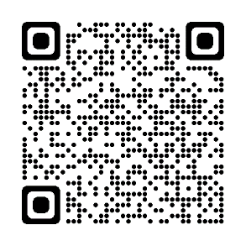
In North Cumbria and the North East, the mental health advisors will be employed by Cumbria, Northumberland, Tyne and Wear NHS Foundation Trust (CNTW).
To find out more, visit the website below or scan the QR code:
northeastnorthcumbria.nhs.uk/nhs-111-select-mental-health-option

